FermiMail

List Owners Guide for ListServ

LISTSERV is a lab wide e-mail list service used to collaborate and share information with a large group of people. This service allows customers to create and maintain e-mail lists through a web interface https://listserv.fnal.gov. This guide is a reference for list owners to use to help answer the most commonly asked questions for list ownership

Getting Started
- How do I manage my list?
- How can I see who has subscribed to my list?
- How can I create Welcome, Farewell and INFO messages?
- Do I need to subscribe to my own list?
- I do (don't) want my list displayed in the public online archives. How can I change that?
- What is the "List Title" and how do I change it?
- How can I change the standard "You are now subscribed" message that gets sent to new subscribers?
- How can I view, add to or delete subscribers from my list?
- How can I add or delete many addresses (bulk add) at one time?
- How can I stop my list from sending messages (prevent new postings from being sent)?
- How can I subscribe one list to another or set up nested lists (sub-lists)?
- What URL can I use to go directly to my list archives?

General Support Information
- What are the most commonly changed configuration?
- Listserv "X-Report-Type:" field found in the mail header
- What is the purpose of Loopcheck=NoSpam?
- How do I restrict my list so that only individuals with AN FNAL email address can send to it?
- All my messages to my list are pre-approved (Send=Editor,Hold,Confirm) and I am getting bombarded with spam. Is it possible to also use the Send=Private option to limit postings to list members only?
- How can I delete unwanted messages from the list archives?
- How Do I Setup Different Types of Lists (moderated, public discussion, etc.)
  - How do I setup a Public Discussion List? (Anyone can subscribe & post)
  - How do I setup a Private Discussion List? (Anyone can subscribe with owner approval, but only list members can post)
  - How do I setup a Basic Edited (Moderated) List? (Only listed editors can post; all other messages are sent to the first editor for approval)
  - How do I setup a Moderated List? (Only listed editors can post; other messages sent to multiple moderators for approval)
  - How do I setup a Self-Moderated List? (Members can post directly to the list but non-member's posts are sent to an editor for approval)
  - How do I setup a Private Moderated List? (All postings from list members are forwarded to the editor/moderator for approval and all postings from non-members are rejected)
  - How do I setup an Announce-only List? (Only the list owner(s) or specific email addresses can post to the list)
  - How do I post to an Edited or Moderated List?
  - I am the list editor/moderator. How do I approve the messages?
  - As the moderator of a list, I get the message for approval plus the posted message. How can I stop getting two copies?
- How can I delete a list?
- I get an email message every time someone subscribes to my list. How do I stop this?
- Can I set my list to require subscribers to renew their subscriptions on a regular basis?
- How do I ban some email addresses from sending or subscribing to my list?
- How can I "hold" or "free" my list?
- How can I completely remove one or both Welcome messages?
- How to Decrease Spam in LISTSERV
- How can I stop an active spammer from posting to a ListServ List?

Getting Started

How do I manage my list?
We recommend that you use the web interface to maintain your list.
- Log into LISTSERV https://listserv.fnal.gov
- Select Manage Your Lists
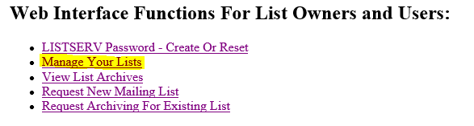
- On the Login Required screen, enter your e-mail address and password.
- Click the Log In button.
- From the List Management dropdown menu select List Dashboard.
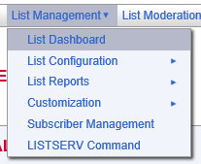
The List Dashboard shows all your lists. The List Dashboard Moderation section alerts you of any messages that are awaiting moderation.
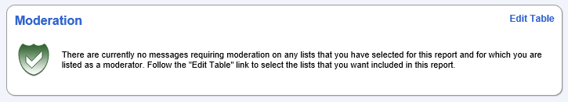
The reports table at the bottom of the screen shows list configuration and list activity.
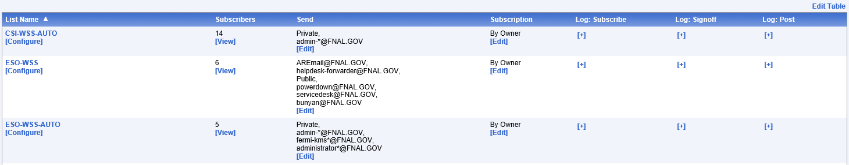
Many list configuration options are available directly from the List Dashboard. From here you can configure your lists and view, add or delete subscribers.
Lists can be configured using a wizard, which guides you step-by-step through the configuration process or manually.
- To open the List Configuration Wizard, click the List Management menu, click List Configuration, and then click List Configuration Wizard.
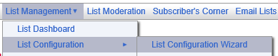
- To manually configure the list click the List Management menu, click List Configuration, and click Manual List Configuration.
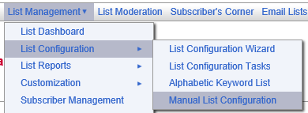

You can also maintain your list via e-mail. Please refer to the "LISTSERV 16.0 List Owner's Manual" which is available at L-Soft Documentation and Manuals .
- Send an e-mail message to listserv@fnal.gov.
- Leave the subject line blank
- Put the command in the body of the message.

How can I see who has subscribed to my list?
There are several ways to view subscribers:
- Select List Management > Subscriber Management.
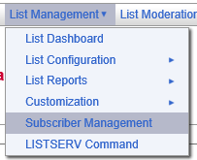
  - If not already selected Select List
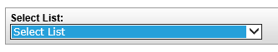
  - At the bottom left in the "Review list members:" section, click In Browser or By Email.
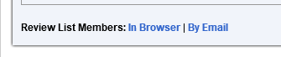
- You can view your list subscribers by using the List Dashboard - click List Management > List Dashboard. Click on [View] in the Subscribers column.
- You can view list subscribers by clicking List Management > List Reports > Subscriber Reports. Click the down arrow for Select List and select your list. The subscribers will be listed in the Subscriber Names column.
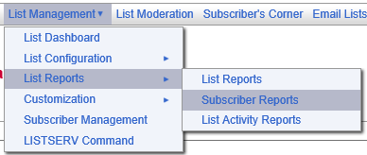
- You can view list subscribers via email.
  - Send an e-mail message to listserv@fnal.gov.
  - Leave the subject line blank
  - Put the command in the body of the message:
REVIEW LISTNAME NOH ALL TOPICS BY NAME

How can I create Welcome, Farewell and INFO messages?
To create or change your Welcome, Farewell and INFO messages:
- Log into LISTSERV https://listserv.fnal.gov.
- Select List Management > List Configuration > List Configuration Tasks
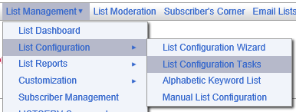
- If you own more than one list, use the drop-down arrow in Select List: to select your list
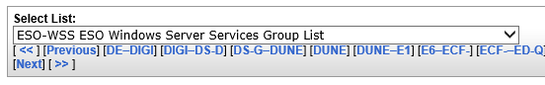
- Select the Mail Templates tab
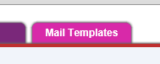
- Select the mail template you want to update
- Make your modifications
- Click Update

Do I need to subscribe to my own list?
Only if you want to see the messages sent to the list will you need to subscribe to your own list.

I do (don't) want my list displayed in the public online archives. How can I change that?
Do you want to advertise your list on the public online archives web site and make the listname available via e-mail on the list-of-lists? This convenience to your users may increase the risk of receiving spam on this list.
To change the configuration setting for displaying the list:
- Log into LISTSERV https://listserv.fnal.gov.
- Select List Management > List Configuration > List Configuration Tasks
- If you own more than one list, use the drop-down arrow in Select List: to select your list
- Select the Security tab
- Set Confidential = Yes to hide your list, or Confidential = No to display your list.
- Click on Save at the bottom of the page.
- You should see the message "The header of the LISTNAME list has been successfully replaced."

What is the "List Title" and how do I change it?
The List Title is a one-line description, maximum of 100 characters, of the list which is assigned when the list is created. This description is automatically included in the mail message sent to new subscribers. This description also appears in the online web archives listing.
To change the List Title:
- Log into LISTSERV https://listserv.fnal.gov.
- Select List Management > List Dashboard
- If you own more than one list, use the drop-down arrow in Select List: to select your list
- Click on [Configure]
- This first line in the list header is the "List Title"
- Type in your new List Title
- Click on Save at the bottom of the page
- You should see the message "The header of the LISTNAME list has been successfully replaced."

How can I change the standard "You are now subscribed" message that gets sent to new subscribers?
There are three possible places to change this message.
- The SIGNUP1 or "You are now subscribed to the &LISTNAME list" template which includes/imbeds the $SIGNUP template.
- The ADD1 or "You have been added to the &LISTNAME list" template which includes/imbeds the $SIGNUP template.
- The $SIGNUP or "Standard message to new subscribers " template.
When a user subscribes to a list, LISTSERV sends the SIGNUP1 message.
When a list owner manually adds a subscriber to a list, LISTSERV sends the ADD1 message, unless "Do Not Notify the User" has been selected.
By default, both the SIGNUP1 and the ADD1 messages imbed the $SIGNUP message by including a .im $SIGNUP command in those message templates.
To eliminate the SIGNUP1 and the ADD1 messages, edit those messages as described below. Add the .QQ command as the first line of each template. This will cancel the message.
To change these messages:
- Log into LISTSERV https://listserv.fnal.gov.
- Select List Management > List Dashboard
- If you own more than one list, use the drop-down arrow in Select List: to select your list
- Select the Mail Templates tab
- Make your modifications
- Click Update

How can I add to or delete subscribers from my list?
Adding A New Subscriber
- Log into LISTSERV https://listserv.fnal.gov.
- Select your list and click List Management > Subscriber Management.
- If you own more than one list, use the drop-down arrow in Select List: to select your list
- Select the Single Subscriber tab
- In the Add New Subscriber section, type the email address and name.
- Click the Add to LISTNAME button.

Deleting A Subscriber
- Log into LISTSERV https://listserv.fnal.gov.
- Select your list and click List Management > Subscriber Management.
- If you own more than one list, use the drop-down arrow in Select List: to select your list
- Select the Single Subscriber tab
- In the Examine or Delete Subscription section, type the email address of the person to remove.
- Click the Search in LISTNAME button.
- Select your options
- Click on Delete

How can I add or delete many addresses (bulk add) at one time?

Using the web interface
- Log into LISTSERV https://listserv.fnal.gov.
- Select your list and click List Management > Subscriber Management.
- If you own more than one list, use the drop-down arrow in Select List: to select your list
- Select the Bulk Operations tab
- Read the functions carefully before making your selection since some of the functions will remove all subscribers from your list
The input file must be a plain text file (with the extension of .txt) and must contain one address per line, optionally followed with a space (or TAB) and the subscriber's name. The input file cannot contain quotes. For example:
emailaddress firstname lastname
emailaddress
To add subscribers to lists in bulk using e-mail commands
- Address a message to: listserv@fnal.gov
- Leave the subject line blank
- In the body of the message type:
quiet add LISTNAME dd=ddname import pw=yourlistservpassword
//ddname dd *
emailaddress1 firstname lastname
emailaddress2 firstname lastname
emailaddress3 firstname lastname
/*
To remove subscribers from lists in bulk using e-mail commands
- Address a message to: listserv@fnal.gov
- Leave the subject line blank
- In the body of the message type:
quiet del LISTNAME dd=ddname brief pw=yourlistservpassword
//ddname dd *
emailaddress1
emailaddress2
emailaddress3
/*

How can I stop my list from sending messages (prevent new postings from being sent)?
Example: My list keeps sending the same message over and over again (looping). How can I stop my list from sending any messages until I get the problem fixed?
You can prevent new posting from being processed by issuing "hold" command. This will hold all messages until a "free" command is issued.
- Log into LISTSERV https://listserv.fnal.gov.
- Select List Management > LISTSERV Command
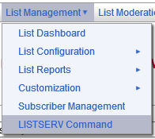
- I If you own more than one list, use the drop-down arrow in Select List: to select your list
- Under Useful Commands: select Hold LISTNAME
- To release the hold and resume emails Under Useful Commands: select Free LISTNAME

How can I subscribe one list to another or set up nested lists (sub-lists)?
LISTSERV offers "super-lists" and "sub-lists".
With a super-list, the membership of all the sub-lists is added and duplicates are suppressed. The super-list is a normal list with its own archives, access controls, etc. List owners may convert a standard list that they own into a super-list, but they may only add other lists that they own to the Sub-Lists= setting
For more information see L-Soft Documentation Click on the LISTSERV 16.0 List Owner's Manual link and see Section 12.13.12 Super-Lists and Sub-Lists.

What URL can I use to go directly to my list archives?
https://listserv.fnal.gov/scripts/wa.exe?INDEX

General Support Information

What are the most commonly changed configuration?
Detailed information for key words can be found in the L-Soft List Keyword Reference.
Help can also be found by selecting List Management > List Configuration > Alphabetic Keyword List
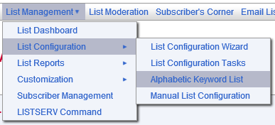
List Owner Information--
To add or change the list owner, select List Management > List Configuration > Manual List Configuration and modify
Owner = EmailAddressOne,EmailAddressTwo....

Who can subscribe to the list?
Subscription =
- Open,Confirm -> Anyone can subscribe to the list. They must confirm their address with an "OK" response. No list owner intervention is required.
- By_Owner -> New users are not allowed to subscribe. Their requests are forwarded to the list owner.
- By_Owner,Confirm -> Same as "By_ Owner" with the addition that the subscriber must first confirm their address with an "OK" response.
- Closed -> New users are not allowed to subscribe. Their requests are "bounced" back to the sender, i.e., the list owner does not see the requests.

Who can post (send) messages to the list?
Send =
- Public,Confirm -> Anyone can send to the list.
- Private,Confirm -> Only list members can send to the list.
- Owner,Confirm -> Only the owner can send to the list. Messages are "bounced" back to the sender.
- Editor,Hold, Confirm
Editor = editors_emailaddress -> All messages are sent to the editor for approval.

Should the listname be shown on the online archives web page and the e-mail list-of-lists?
Confidential =
- No -> Display the listname.
- Yes -> Keep the listname confidential.

Who can view the online archives?
Notebook =
- Public -> Anyone can view the online archives.
- Private -> Only list members can view the online archives.
- Owner -> Only the list owner can view the online archives.

Who can review the list of subscribers?
Review =
- Public -> Anyone can view the list of subscribers.
- Private -> Only list members can view the list of subscribers.
- Owner -> Only the list owner can view the list of subscribers.

To whom should the replies go?
Reply-to =
- Sender,Respect -> Replies are directed to the original sender. The original "Reply-to", if any, is kept.
- List,Ignore -> Replies are directed to the list address. The original "Reply-to", if any, is ignored and discarded.

Listserv "X-Report-Type:" field found in the mail header
List owners may receive an error message that reads:
>> The enclosed message, found in the listname mailbox and shown under the spool ID xxxx in the system log, has been identified as a possible delivery error notice for the following reason: "X-Report-Type:" field found in the mail header

The list owner should click on the attachment included with this message. The attachment will give them more information about the specific error.
The attachment may read:
This is an automatically generated Delivery Status Notification.
Delivery to the following recipients failed.
janedoe@example.com
In this example, the attachment tells the list owner that the message was unable to be delivered to the recipient. This could be because the subscriber is over quota or the address is no longer valid. If the list owner continues to receive this error message, it is best to remove the subscriber from the list.
This error message occurs when a message cannot be delivered to one or more recipients. The recipient's email address may be incorrect

What is the purpose of Loopcheck=NoSpam?
A list owner who sends to multiple lists may wish to add the Loopcheck = NoSpam setting to their LISTSERV configuration file to prevent themselves from being identified as a possible spammer. We would only recommend adding this setting to moderated lists, where the moderator can then prevent spam messages from being sent to the entire list.

How do I restrict my list so that only individuals with AN FNAL email address can send to it?
It is possible to use the wildcard symbol to limit postings to @fnal.gov addresses only. The following option in the list header configuration will limit postings to the list owner and anyone with a @fnal.gov address:
Send= Owner,*@fnal.gov,Confirm

All my messages to my list are pre-approved (Send=Editor,Hold,Confirm) and I am getting bombarded with spam. Is it possible to also use the Send=Private option to limit postings to list members only?
We recommend you set your list to:
Send = Editor,Hold,Confirm,All
This will require the spammer to confirm that they sent the message. See How to Decrease Spam to LISTSERV for details on using these settings.

How can I delete unwanted messages from the list archives?
- Log into LISTSERV https://listserv.fnal.gov.
- Select List Management > List Dashboard
- If you own more than one list, use the drop-down arrow in Select List: to select your list
- Click the listname to go to the list archives page
- Select the appropriate month
- Find the message you wish to delete
- Click the Delete button to the right of the message

How Do I Setup Different Types of Lists (moderated, public discussion, etc.)
For information concerning different types of lists see the List Owner's Manual section 12.13 Setting Up Lists for Specific Purposes for more detailed information. Also, you can review LISTSERV 16.0 List Keyword Reference.
For online help about each keyword:
- Log into LISTSERV https://listserv.fnal.gov.
- Select List Management > List Configuration > Alphabetic List
- Select the desired keyword for detailed help

How do I setup a Public Discussion List? (Anyone can subscribe & post)
Set the list configuration settings to:
Subscription = Open,Confirm
Send = Public,Confirm
Notebook = ......,Private
This configuration will:
- Allow anyone to subscribe to the list (Subscription = Open).
- A confirmation e-mail will be sent to the subscriber (Subscription = ...., Confirm).
- Anyone can to post directly to the list (Send=Public).
- A confirmation e-mail will be sent to the sender (Send = ...., Confirm).
- Only list members can view the list archives. (Notebook=....,Private).
See the List Owner's Manual section 2.13 Setting Up Lists for Specific Purposes for more detailed information.

How do I setup a Private Discussion List? (Anyone can subscribe with owner approval, but only list members can post)
Set the list configuration settings to:
Subscription = By_Owner,Confirm
Send = Private,Confirm
Notebook = ......,Private
This configuration will:
- Subscription requests are forwarded to the list owner (Subscription=By_ Owner) after the requestor confirms that they sent the request (Subscription=....,Confirm).
- Only list members can post directly to the list (Send=Private). Other messages will bounce to the sender.
- Only list members can view the list archives. (Notebook=....,Private)
See the List Owner's Manual section 2.13 Setting Up Lists for Specific Purposes for more detailed information.

How do I setup a Basic Edited (Moderated) List? (Only listed editors can post; all other messages are sent to the first editor for approval)
A basic edited list allows the Editor(s) to send directly to the list.
All other messages are sent to the first editor listed for approval or rejection. If you need to have more than one person approving the messages, see "How do I set up a moderated list?" below.
Set the list header settings to:
Send = Editor,Hold,Confirm,All
Editor = UserName@fnal.gov,firstname2-lastname2@fnal.gov
where UserName@fnal.gov is a valid e-mail address. The first editor must be a real address, not an access-level such as "Owner".
This is called an "edited" list. More than one editor may be listed, but only the first one listed will receive copies of messages for approval. All editors may post directly to the list.
See the List Owner's Manual section 2.13 Setting Up Lists for Specific Purposes for more detailed information.

How do I setup a Moderated List? (Only listed editors can post; other messages sent to multiple moderators for approval)
A moderated list is similar to an edited list or announce-only list, but allows multiple persons to approve or reject the messages.
The editor(s) can still send directly to the list.
All other messages are sent to the moderators for approval or rejection.
Set the list header settings to:
Send = Editor,Hold,Confirm,All
Editor = UserName@fnal.gov,firstname2-lastname2@fnal.gov
Moderator = UserName@fnal.gov,someotherfirstname-someotherlastname@fnal.gov
where UserName@fnal.gov is a valid e-mail address. The first editor must be a real address, not an access-level such as "Owner". All moderators must also be listed as editors. All editors are not required to be moderators.
This list will "load-share" meaning, the first message will go to UserName@fnal.gov for approval, the second message will go to someotherfirstname-someotherlastname@fnal.gov, etc.
To have all the messages go to all of the moderators each time, add "All" before the list of addresses:
Moderator = All,UserName@fnal.gov,someotherfirstname-someotherlastname@fnal.gov
Note: The All, must be before the list of moderators.
Once the message has been approved by one of the moderators the message is sent. Other attempts to approve the message will indicate that the message has already been approved. It will not be sent more than once.
See the List Owner's Manual section 2.13 Setting Up Lists for Specific Purposes for more detailed information.

How do I setup a Self-Moderated List? (Members can post directly to the list but non-member's posts are sent to an editor for approval)
A self-moderated list allows list member to post directly to the list but non-member's posts are sent to an editor for approval.
Set the list header settings as shown below. Be sure to include the listname in parentheses on the Editor keyword.
Send = Editor,Hold,Confirm,All
Editor = UserName@fnal.gov, (listname)
where UserName@fnal.gov is a valid e-mail address and listname is the name of your list. Be sure to include the parenthesis. The first editor must be a real address, not an access-level such as "Owner".
See the List Owner's Manual section 2.13 Setting Up Lists for Specific Purposes for more detailed information.

How do I setup a Private Moderated List? (All postings from list members are forwarded to the editor/moderator for approval and all postings from non-members are rejected)
A private moderated list causes all postings from list members to be forwarded to the editor/moderator for approval and rejects all postings from non-members.
Set the list configuration settings to:
Subscription = By_Owner,Confirm
Send = Private,Confirm
Editor = UserName@fnal.gov,....
Notebook = ......,Private
Default-Options = Review
Using the web interface, select List Management > LISTSERV Command. If you own more than one list, use the pull-down arrow in the Select List: field to select the correct list.
In the Command: field type the following command:
QUIET SET listname REVIEW FOR *@*
Press Enter Command.
The editors will need to set themselves to NOREVIEW or they will have to approve their own postings also.
This configuration will:
- Subscription requests are forwarded to the list owner (By_ Owner) after the requestor confirms that they sent the request (,Confirm).
- Only list members can post to the list (Send=Private). Other messages will bounce to the sender.
- All postings from new list members will be sent to the editor/moderator for approval (Default-options - Review).
- All current list members will be set to the Review option (QUIET SET listname REVIEW FOR *@*) and thus their postings will also be sent to the editor/moderator for approval.
- Only list members can view the list archives. (Notebook=....,Private)
See the List Owner's Manual section 2.13 Setting Up Lists for Specific Purposes for more detailed information.

How do I setup an Announce-only List? (Only the list owner(s) or specific email addresses can post to the list)
Only the list owner(s) or specific email address can post to an announce-only list.
Set the list configuration settings to:
Send= Owner,Confirm
Reply-To= firstname1-lastname1@fnal.gov,ignore
Or
Send= UserName@fnal.gov,Confirm
Reply-To= firstname1-lastname1@fnal.gov,ignore
where UserName@fnal.gov and firstname1-lastname1@fnal.gov are valid e-mail addresses.
With this set up:
- Only the list owner(s) (or UserName@fnal.gov) will be able to post directly to the list.
- The reply-to will always be set to firstname1-lastname1@fnal.gov (the ignore setting).
This could be a special account set up to handle responses.
This setting will require the list owner to confirm all postings. This helps to prevent hackers from forging the list owner's e-mail address. This may also help prevent mail looping problems.
See the List Owner's Manual section 2.13 Setting Up Lists for Specific Purposes for more detailed information.

How do I post to an Edited or Moderated List?
Whether you are a list member or the editor or moderator, simply send the message to listname@list.fnal.gov
Messages posted from the list editors will be automatically sent on with no approval required. If the list configuration headers are set to Send=Editor,Hold,Confirm a confirmation message will be sent to that editor. This is for security to ensure that a hacker has not faked the sending address.
All other messages will be sent to either the first listed editor, for a basic edited list, or the list moderators, for a moderated list.
See the List Owner's Manual section 15 Moderating and Editing Lists through Email for more detailed information.

I am the list editor/moderator. How do I approve the messages?
If the list header settings are set to:
Send=Editor,Hold,Confirm,xxxx
The editor/moderator will receive the following message:
For security reasons, the ESO-WSS-TEST list has been configured to request positive confirmation of messages posted to the list. You must now confirm that the enclosed message did originate from you. To do so, simply reply to the present message and type "OK" (without the quotes) in the text of your message, or click on the link below. If this does not work, or if the message did not originate from you, then contact the list owner for assistance.

To APPROVE the message:
https://listserv.fnal.gov/scripts/wa.exe?OK=407C4C8E&L=LISTNAME
The above message will include a copy of the message submitted for your approval.
To approve the above message, either
- Click on the URL provided
- Reply with just "ok" as the body of your message (only if HOLD is specified on the Send keyword)
- Or use the LISTSERV Web Interface to approve the message:
  - Log into LISTSERV https://listserv.fnal.gov.
  - Select List Management > List Moderation
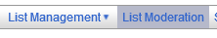
  - Review the message
  - Select the action
  - Click Submit
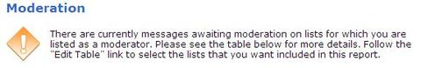
- Click Moderate next to the list you wish to moderate
- Follow on-screen instructions. If you select List Moderation directly from the toolbar, you must select All Moderators and Refresh to see the messages waiting your approval.
The posting will appear to come from the original sender, Username@FNAL.GOV
You can also edit the message and resend it to the list, but the posting will appear to come from you, the editor, Editorname <EditorUserName@fnal.gov>
+++++
If you always need to edit the messages before sending them on you can change the list configuration headers to (remove the HOLD):
Send=Editor,Confirm,xxxx
See the List Owner's Manual section 15 Moderating and Editing Lists through Email for more detailed information.

As the moderator of a list, I get the message for approval plus the posted message. How can I stop getting two copies?
As the moderator, you are not required to also be subscribed to the list. Simply unsubscribe yourself from the list.

How can I delete a list?
Submit a ticket through the Service Request Catalog. Under Email & Calendaring select Maintain Listserv Lists, select Delete Listserv List and fill in the requested information
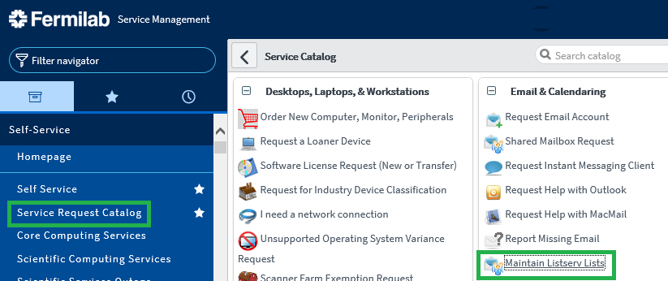

I get an email message every time someone subscribes to my list. How do I stop this?
Set the list header settings to:
Notify=no
Or set the Quiet: option for some of the list owners in the Owner= header setting, for example:
Owner=Username1@fnal.gov,Quiet:, Username2@fnal.gov
See the List Keyword Reference for LISTSERV for more information.

Can I set my list to require subscribers to renew their subscriptions on a regular basis?
Yes, this can be done using the Renewal header setting. You can also have LISTSERV probe for bad e-mail addresses.
See the List Keyword Reference for LISTSERV for more information.

How do I ban some email addresses from sending or subscribing to my list?
This can be done using the "Filter" list keyword in the list header. In the list headers set:
Filter = Also,e-mail-address-to-filter
where: e-mail-address-to-filter is the address to be banned.
See the List Keyword Reference for LISTSERV for more information.

How can I "hold" or "free" my list?
Under List Management select LISTSERV Command. Under Useful Commands select Free listname or Hold listname.

How can I completely remove the welcome message?
- Log into LISTSERV https://listserv.fnal.gov.
- Select List Management > List Configuration > List Configuration Tasks
- If you own more than one list, use the drop-down arrow in Select List: to select your list
- Select the Mail Templates tab
- At the top of the Contents section add a new line and type: “.QQ" (without the quotes). This will cancel the message.
- Click Update

How to Decrease Spam in LISTSERV
Anti-Spam: Why Set Your List to Send=Public,Confirm or Send=Private,Confirm
By adding the Confirm option, the sender will be required to confirm their message before it is posted to the list. This reduces the problem of spammers posting to your list by faking the return address.
What difference will your users experience?
When someone sends an email message to your list, LISTSERV will respond to the sender with the following message:
To cut down on spam, the LISTNAME list has been configured to request
positive confirmation of messages posted from email addresses not currently
subscribed to the list. You must now confirm that the enclosed message did
originate from you. To do so, simply reply to the present message and type "OK"
(without the quotes) in the text of your message, or click on the link below.
If this does not work, or if the message did not originate from you, then
contact the list owner for assistance.
To APPROVE the message:
https://LISTSERV.FNAL.GOV/scripts/wa.exe?OK=2E1C8995&L=LISTNAME
The sender must either reply to the message with OK (as described above) or click on the link provided in the email.
If they choose to click on the link, LISTSERV will return:
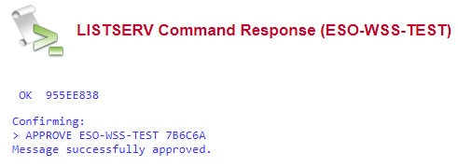
Anti-Spam: Tips to Decrease Spam to the List
Send Keyword Settings:
- Send = Private,Confirm <- Recommended default setting for non-moderated lists.
Only members of the list can send to the list.
- Send =Public,Confirm
Anyone can send to the list.
- Send = Public,Confirm,Non-Member
These options allow anyone to post to the list, but if the sender address is not subscribed to the list, the sender must confirm their message before it is posted to the list. List members do not need to confirm their messages.
- Send=Owner,Confirm
Only the list owners can send to the list.
- Send=Username1@fnal.gov, Username2@fnal.gov,Confirm
Only the email addresses listed can send to the list.
- Send = Editor,Hold,Confirm,All
All messages must be approved by the editor (moderator) before being posted to the list.
- Send = Service,Confirm
Service = *fnal.gov,*.fnal.gov
Filter=also,*@list.fnal.gov
Setting the above Send and Service keywords will limit the allowed senders to fnal.gov addresses.
Setting Filter=also,*@list.fnal.gov disallows messages sent with the fake email return addresses of other LISTSERV lists.
Details about the service keyword are available at:
http://www.lsoft.com/manuals/15.5/listkeyw.html#kService
Additional Keyword Settings:
- Confidential = Yes <- Recommended default setting for lists.
Setting the Confidential command to Yes, removes the name of the list from the public list-of-lists.
- Subscription = xxxxxxxx,Confirm
The Confirm option requires the sender to confirm their subscription.
- Moderated or Announce-Only lists. You also set your list as moderated or announce-only.
- More tips can be found at Tech Tip (LISTSERV) - Issue 3 - 2007 by L-Soft.

How can I stop an active spammer from posting to a ListServ List?

- Log in to the LISTSERV Web interface at http://listserv.fnal.gov
- Select your list and click List Management > Subscriber Management.
- If you own more than one list, use the drop-down arrow in Select List: to select your list
- Select the Single Subscriber tab
  - In the Add New Subscriber section, type the email address that is sending the spam.
  - Select Do Not notify the User
  - Click the Add to LISTNAME button.
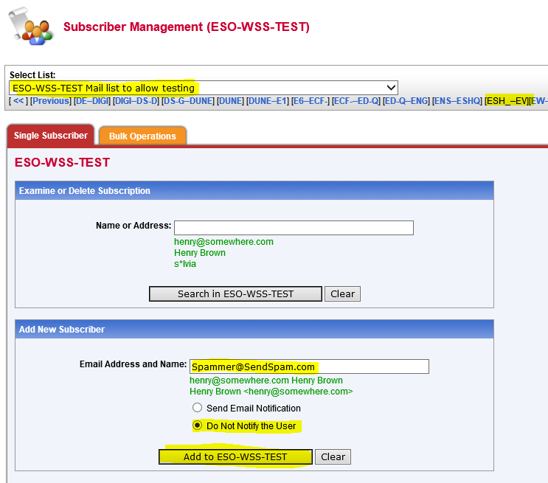
- Select List Management > List Dashboard
- Find the list you are updating and under Subscribers click on View
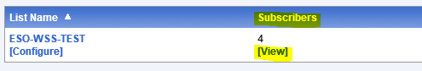
- In the subscriber’s section perform these steps
  - Check the box next to the email address you just added
  - Under Mail Status select No Mail from the pull-down list
  - Under Restrictions select No Post from the pull-down list
  - Click on Submit
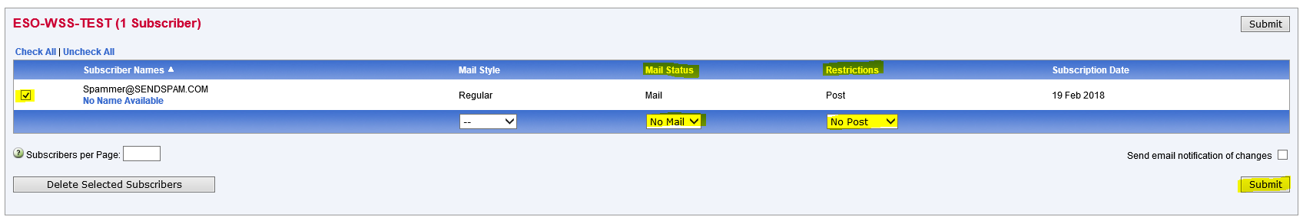
Send test emails to the list to verify you are receiving good emails.
Spam from specific addresses does eventually stop so you can add this configuration and then at a later date remove it once the spam has ceased to help keep your list configuration clean if desired.

